**Two papers by Pengfei Han**

Does Trading Spur Specialization? Evidence from Patenting

<https://papers.ssrn.com/sol3/papers.cfm?abstract_id=3681360>

Firm level panel DID and DDD designs; y是log(专利数量+1)，这个企业level的构造跟我们的不太相似。但是log(p+1)的构造可以借鉴。

Han, Pengfei. Intellectual Property Rights and the Theory of the Innovating Firm. Working Paper, 2018.

<https://pdfs.semanticscholar.org/ca53/77d282e6fc34c2ef1cbd3810b16595d42e89.pdf>

这篇文章主要是一个完整的模型。

empirical的部分关注重点是用是否引用了相同的patent来计算新专利的 distance从而推测出有更高的specialization，也还是对于我们的不太相似。

**Energy Innovation Frontier**

Aghion, Philippe, Lint Barrage, and David Hémous. "Climate Change, Directed Innovation, and Energy Transition: The Long-run Consequences of the Shale Gas Revolution." (2019).

Tracing the Linkages between Scientific Research and Energy Innovations: A Comparison of Clean and Dirty Technologies; Robert K. Perrons, Adam B. Jaffe, Trinh Le; NBER working paper, September 2020

<https://www.nber.org/papers/w27777.pdf>

对于为什么能源领域的创新那么慢，学界还没有什么答案。大部分文章专注于投资对于个别领域的能源创新的影响。这篇文章围绕从“非专利论文”到“专利”，利用专利数据和引用数据，比较dirty和clean所需要的时间，平均引用多少文章。结论是clean更依赖于引用。

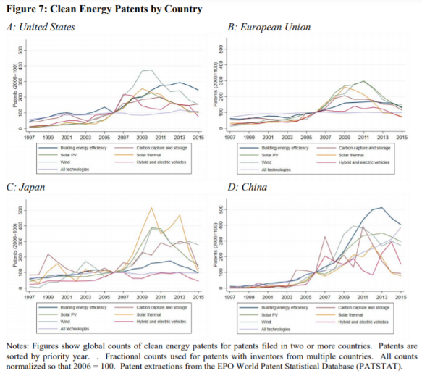

Popp, David, et al. *Innovation and Entrepreneurship in the Energy Sector*. No. w27145. National Bureau of Economic Research, 2020. <https://www.nber.org/papers/w27145.pdf>

能源领域的创新越来越依赖于其他高技术行业的发展，two descriptive data analyses that document a sharp decline in both clean energy patenting and start-up activity from about 2010 onwards:

1. Energy price?
2. Technology of hydro-fracturing?
3. Diminishing return to innovation?
4. Innovation has worked?
5. Weakened regulation in Obama era?

EPO World Patent Statistical Database (PATSTAT): 包含中国的专利数据，这个数据跟我们的有何不同？

Popp, David. "Promoting Clean Energy Innovation at the State and Local Level." Agricultural and Resource Economics Review (2020): 1-14. <https://www.cambridge.org/core/services/aop-cambridge-core/content/view/5AD1CD8946541A2098690F8F303853DB/S1068280520000155a.pdf/div-class-title-promoting-clean-energy-innovation-at-the-state-and-local-level-div.pdf>

Technology-neutral policy (carbon cap-n-trade, clean energy mandate) favors clean energy that is most profitable. 因此不是所有清洁能源的创新都得到同等程度的刺激。

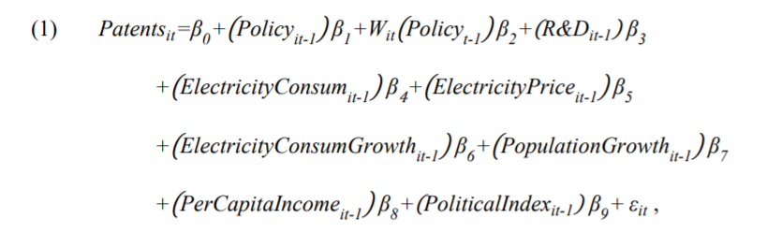Fu, Wancong, et al. Technological spillover effects of state renewable energy policy: Evidence from patent counts. No. w25390. National Bureau of Economic Research, 2018. <https://www.nber.org/papers/w25390.pdf>

我们可能要用这篇文章提到的**semiparametric fixed-effects Tobit model**

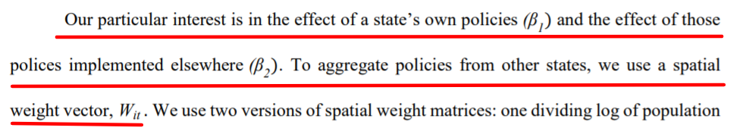We use two versions of spatial weight matrices: one dividing log of population by distance, and a second with identical non-zero weights only when states share a common border.